Project Report Format
1. INTRODUCTION
1.1 Project Overview
1.2 Purpose
2. IDEATION PHASE
2.1 Problem Statement
2.2 Empathy Map Canvas
2.3 Brainstorming
3. REQUIREMENT ANALYSIS
3.1 Customer Journey map
3.2 Solution Requirement
3.3 Data Flow Diagram
3.4 Technology Stack
4. PROJECT DESIGN
4.1 Problem Solution Fit
4.2 Proposed Solution
4.3 Solution Architecture
5. PROJECT PLANNING & SCHEDULING
5.1 Project Planning
6. FUNCTIONAL AND PERFORMANCE TESTING
6.1 Performance Testing
7. RESULTS
7.1 Output Screenshots
8. ADVANTAGES & DISADVANTAGES
9. CONCLUSION
10. FUTURE SCOPE
11. APPENDIX
Source Code(if any)
Dataset Link
GitHub & Project Demo Link

1. INTRODUCTION
Agriculture is one of the most important sectors contributing to economic growth and food security. Farmers often face challenges in selecting suitable crops due to variations in soil nutrients, climatic conditions, and environmental factors. Incorrect crop selection can result in reduced productivity, inefficient utilization of resources, and financial losses. Traditional farming practices mainly rely on experience and manual decision-making, which may not always produce optimal results.
The advancement of Artificial Intelligence (AI) and Machine Learning (ML) has enabled the development of intelligent systems capable of analyzing agricultural data and providing accurate recommendations. By utilizing historical agricultural datasets and predictive algorithms, Machine Learning models can assist farmers in selecting crops that are most suitable for their soil and environmental conditions.
The OptiCrop: Smart Agricultural Production Optimization Engine is a web-based Machine Learning application developed to recommend the most suitable crop based on soil nutrient values and climatic parameters. The system analyzes important agricultural inputs such as Nitrogen (N), Phosphorus (P), Potassium (K), temperature, humidity, soil pH, and rainfall to generate crop recommendations using a trained Machine Learning model.
The project follows a structured Software Development Life Cycle (SDLC), including problem identification, requirement analysis, system design, implementation, testing, and evaluation. The developed application provides a simple and user-friendly interface, enabling farmers to obtain crop recommendations quickly and efficiently.
The primary objective of this project is to demonstrate how Machine Learning can support agricultural decision-making by providing accurate crop recommendations. The system helps farmers make informed cultivation decisions, improve agricultural productivity, and promote efficient utilization of available resources.

1.1 Project Overview
OptiCrop is a Machine Learning-based crop recommendation system designed to assist farmers in selecting suitable crops according to soil characteristics and environmental conditions. The application enables users to enter agricultural parameters and receive intelligent crop recommendations through a web-based interface.
The application has been developed using Python and the Flask framework, while the Machine Learning model is implemented using Scikit-learn. The frontend is developed using HTML, CSS, and JavaScript to provide a simple and responsive user interface. The prediction model is trained using a publicly available Crop Recommendation Dataset containing soil nutrients and climatic parameters.
The overall workflow of the application includes collecting agricultural inputs from the user, validating the entered values, processing the data using the trained Machine Learning model, and displaying the recommended crop. The system provides fast predictions and helps farmers make informed decisions regarding crop selection.

1.2 Purpose
The primary purpose of this project is to develop an intelligent crop recommendation system that assists farmers in selecting the most suitable crop based on soil nutrient values and environmental conditions. The application uses Machine Learning techniques to analyze agricultural data and generate accurate recommendations that support better farming decisions.
The project addresses the common challenge of crop selection by reducing dependence on manual analysis and traditional farming practices. By utilizing historical agricultural datasets and predictive analytics, the system helps farmers choose crops that are compatible with their soil conditions and climatic environment.
Furthermore, the project demonstrates the practical application of Artificial Intelligence and Machine Learning in agriculture. It serves as a foundation for future enhancements such as fertilizer recommendation, disease detection, weather integration, and irrigation management, contributing towards the development of intelligent and sustainable farming solutions.

2. IDEATION PHASE
The ideation phase focused on identifying the major challenges faced by farmers during crop selection and exploring technological solutions to address these problems. Various agricultural issues were studied, including improper crop selection, changing climatic conditions, and inefficient utilization of soil resources. The objective was to develop a practical and user-friendly solution that could assist farmers in making informed cultivation decisions.
A design thinking approach was adopted to understand farmers' needs, identify pain points, generate possible solutions, and select the most feasible approach. After evaluating several ideas, a Machine Learning-based crop recommendation system was chosen as the proposed solution due to its simplicity, effectiveness, and practical applicability.

2.1 Problem Statement
Selecting the appropriate crop is one of the most important decisions in agriculture. Farmers often rely on traditional knowledge and personal experience to determine which crops should be cultivated. However, variations in soil nutrient composition and environmental conditions make this process difficult and may lead to poor crop yield and inefficient use of agricultural resources.
There is a need for an intelligent system that analyzes soil and climatic parameters to recommend the most suitable crop. Such a system can assist farmers in making informed decisions based on data rather than assumptions.
The proposed OptiCrop system addresses this problem by using Machine Learning techniques to analyze agricultural parameters and recommend the most suitable crop for cultivation, thereby improving productivity and supporting sustainable farming practices.

2.2 Empathy Map Canvas
The empathy map was created to understand the needs, expectations, and challenges of farmers who will use the OptiCrop application.

Thinks
- Wants to maximize crop yield.
- Needs reliable crop recommendations.
- Wants to reduce farming risks.
- Looks for simple technological solutions.

Feels
- Concerned about selecting the wrong crop.
- Worried about financial losses due to poor crop yield.
- Unsure about changing weather conditions.
- Needs confidence before starting cultivation.

Says
- "Which crop is best for my soil?"
- "I want better crop yield."
- "I need a simple recommendation system."
- "I want reliable farming guidance."

Does
- Checks soil conditions.
- Collects information from agricultural experts.
- Monitors weather conditions.
- Selects crops based on experience.

Pains
- Difficulty selecting suitable crops.
- Lack of scientific decision support.
- Reduced productivity due to incorrect crop selection.
- Limited access to intelligent farming tools.

Gains
- Accurate crop recommendations.
- Improved agricultural productivity.
- Better utilization of soil resources.
- Increased confidence in farming decisions.

2.3 Brainstorming
Several ideas were explored during the brainstorming phase to identify an effective solution for improving agricultural productivity. Different approaches were evaluated based on feasibility, implementation complexity, and expected benefits.
The following ideas were considered:
- Machine Learning-based Crop Recommendation
- Soil Nutrient Analysis
- Agricultural Data Analysis
- Farmer-Friendly Web Application
- Intelligent Decision Support System
After evaluating these ideas, a Machine Learning-based crop recommendation system was selected because it effectively addresses the primary challenge of selecting suitable crops based on soil nutrient values and climatic conditions. The solution is simple, scalable, and capable of providing quick recommendations through an easy-to-use web application.
The ideation phase concluded that integrating Machine Learning with a web-based application provides an effective and practical solution for supporting farmers in crop selection and promoting data-driven agricultural practices.

3. REQUIREMENT ANALYSIS
Requirement analysis is a crucial phase in software development that identifies the functional and non-functional requirements of the proposed system. This phase focuses on understanding user needs, defining system functionalities, and selecting appropriate technologies to develop an efficient crop recommendation application.
For the OptiCrop: Smart Agricultural Production Optimization Engine, the requirements were gathered by studying the common challenges faced by farmers in selecting suitable crops based on soil characteristics and environmental conditions. The analysis resulted in the development of a Machine Learning-based crop recommendation system that assists farmers in making informed cultivation decisions.
The primary stakeholder of the system is the farmer, who uses the application to obtain crop recommendations based on agricultural parameters.

3.1 Customer Journey Map
The customer journey illustrates the interaction between the farmer and the OptiCrop application from accessing the system to receiving crop recommendations.

Stage 1 – Access Application
- The farmer opens the OptiCrop web application.
- The home page provides an overview of the system and navigation options.

Stage 2 – Navigate to Dashboard
- The farmer accesses the dashboard.
- The dashboard allows the user to proceed to the crop recommendation module.

Stage 3 – Enter Agricultural Parameters
The farmer enters the required agricultural information:
- Nitrogen (N)
- Phosphorus (P)
- Potassium (K)
- Temperature
- Humidity
- Soil pH
- Rainfall

Stage 4 – Data Validation
The application validates all input values to ensure they are complete and within acceptable ranges before processing.

Stage 5 – Machine Learning Prediction
The trained Machine Learning model analyzes the input parameters and predicts the most suitable crop for cultivation.

Stage 6 – Display Recommendation
The predicted crop is displayed on the result page, allowing the farmer to make informed farming decisions.

3.2 Solution Requirements
The proposed solution is a Machine Learning-powered web application that recommends suitable crops using soil and environmental data.

Functional Requirements
The system shall:
- Display the home page.
- Provide access to the dashboard.
- Accept agricultural input parameters.
- Validate user inputs before prediction.
- Process input data using the trained Machine Learning model.
- Predict the most suitable crop.
- Display the prediction result to the user.
- Provide a simple and user-friendly interface.

Non-Functional Requirements
The system should:
- Produce accurate crop recommendations.
- Generate predictions within a few seconds.
- Provide an intuitive user interface.
- Be reliable and easy to maintain.
- Support future scalability.
- Ensure consistent application performance.

3.3 Data Flow Diagram
The OptiCrop application follows a straightforward flow of information between the user and the Machine Learning prediction model.

Level-0 Data Flow
Farmer
│
▼
Enter Agricultural Parameters
│
▼
Flask Web Application
│
▼
Input Validation
│
▼
Machine Learning Model
│
▼
Crop Prediction
│
▼
Display Recommended Crop

Input Data
The application receives the following agricultural parameters:
- Nitrogen (N)
- Phosphorus (P)
- Potassium (K)
- Temperature
- Humidity
- Soil pH
- Rainfall

Processing
The system performs:
- Input validation
- Data preprocessing
- Machine Learning prediction
- Recommendation generation

Output
The application displays:
- Recommended Crop

3.4 Technology Stack
The OptiCrop system was developed using modern web development and Machine Learning technologies.
Component | Technology Used
Programming Language | Python
Backend Framework | Flask
Frontend | HTML5
Styling | CSS3
Client-side Scripting | JavaScript
Machine Learning Library | Scikit-learn
Data Processing | Pandas, NumPy
Model Serialization | Pickle
Development Environment | Visual Studio Code
Version Control | Git & GitHub
Operating System | Windows
Dataset | Crop Recommendation Dataset

Technology Justification
Python was selected because of its simplicity and extensive support for Machine Learning development.
Flask was used as the backend framework due to its lightweight architecture and seamless integration with Machine Learning models.
Scikit-learn provides efficient classification algorithms that enable accurate crop prediction.
Pandas and NumPy simplify data preprocessing and feature handling before prediction.
HTML, CSS, and JavaScript were used to create a responsive and user-friendly interface for farmers.
Pickle stores the trained Machine Learning model so it can be loaded efficiently during prediction.
The selected technology stack provides a reliable, lightweight, and scalable solution for implementing an intelligent crop recommendation system.

4. PROJECT DESIGN
The project design phase converts the identified requirements into a structured software solution. It defines the architecture, system workflow, and interaction between different components of the application. The design of the OptiCrop system focuses on simplicity, accuracy, and ease of use, enabling farmers to obtain crop recommendations based on soil and environmental parameters.
The application follows a modular architecture consisting of the presentation layer, application layer, Machine Learning prediction layer, and data layer. Each layer performs a specific function, ensuring efficient communication and maintainability of the system.

4.1 Problem–Solution Fit
The primary objective of the project is to assist farmers in selecting the most suitable crop based on soil nutrients and climatic conditions. The developed solution addresses this challenge using a Machine Learning model integrated into a web application.
Identified Problem | Proposed Solution
Difficulty in selecting suitable crops | Machine Learning-based Crop Recommendation System
Dependence on traditional farming knowledge | Data-driven crop prediction using agricultural parameters
Manual analysis of soil conditions | Automated prediction using trained ML model
Lack of digital decision support | User-friendly web application for crop recommendation

Value Delivered
The proposed solution offers the following benefits:
- Provides accurate crop recommendations.
- Supports scientific decision-making.
- Reduces manual effort in crop selection.
- Improves farming productivity.
- Offers a simple and intuitive user interface.
- Encourages the adoption of precision agriculture techniques.
The project demonstrates how Machine Learning can be effectively used to solve practical agricultural problems by providing reliable crop recommendations.

4.2 Proposed Solution
The OptiCrop system is a web-based Machine Learning application that predicts the most suitable crop based on soil nutrient values and environmental conditions.
The overall workflow of the system is as follows:
- The user opens the OptiCrop application.
- The Home Page introduces the application and provides navigation.
- The user accesses the Dashboard.
- Agricultural parameters are entered:
  - Nitrogen (N)
  - Phosphorus (P)
  - Potassium (K)
  - Temperature
  - Humidity
  - Soil pH
  - Rainfall
- The Flask application validates the input values.
- The trained Machine Learning model processes the input data.
- The predicted crop is displayed on the Result Page.

Functional Modules

Home Page
Provides an introduction to the OptiCrop application and allows users to navigate to the crop recommendation module.

Dashboard
Acts as the main navigation page and provides access to the crop recommendation feature.

Crop Recommendation Module
Accepts soil and environmental parameters from the user and forwards them to the Machine Learning model for prediction.

Result Module
Displays the predicted crop based on the analysis performed by the Machine Learning model.

4.3 Solution Architecture
The OptiCrop application follows a four-layer architecture that separates the user interface, application logic, Machine Learning model, and data resources.

Presentation Layer
This layer provides the graphical user interface through which users interact with the system.
Components include:
- Home Page
- Dashboard
- Crop Recommendation Form
- Result Page
Technologies Used:
- HTML5
- CSS3
- JavaScript

Application Layer
The application layer handles all business logic and communication between the user interface and the Machine Learning model.
Responsibilities include:
- Receiving user inputs
- Input validation
- Data preprocessing
- Sending data to the prediction model
- Displaying prediction results
Technology Used:
- Flask (Python)

Machine Learning Layer
This layer performs the crop prediction using a trained Machine Learning model.
Responsibilities include:
- Loading the trained model
- Processing input features
- Predicting the most suitable crop
- Returning prediction results
Libraries Used:
- Scikit-learn
- Pandas
- NumPy
- Pickle

Data Layer
The data layer stores the agricultural dataset and the trained Machine Learning model used for prediction.
Resources include:
- Crop Recommendation Dataset
- Trained Machine Learning Model (.pkl)

System Workflow
User
│
▼
Home Page
│
▼
Dashboard
│
▼
Crop Recommendation Form
│
▼
Flask Application
│
▼
Input Validation
│
▼
Machine Learning Model
│
▼
Crop Prediction
│
▼
Result Page

Architectural Benefits
The proposed architecture provides several advantages:
- Simple and modular design.
- Fast prediction using a trained Machine Learning model.
- Easy maintenance and future enhancement.
- Clear separation between user interface and prediction logic.
- Lightweight implementation using Flask.
- Scalable architecture for integrating additional agricultural services in the future.
The architecture successfully integrates Machine Learning with a web application, enabling farmers to obtain accurate crop recommendations through a simple and efficient interface.

5. PROJECT PLANNING & SCHEDULING
Project planning and scheduling play a vital role in ensuring the successful development of a software system. This phase involves defining project objectives, identifying key activities, allocating resources, estimating timelines, and monitoring progress throughout the Software Development Life Cycle (SDLC). Proper planning minimizes risks, improves coordination among team members, and ensures that the project is completed within the specified time frame.
The OptiCrop project was developed using a phased approach, where each stage built upon the outcomes of the previous phase. The project followed a systematic workflow beginning with problem identification, requirement gathering, system design, implementation, testing, and final deployment. Regular reviews and validations were conducted to ensure that each milestone met the project objectives.

5.1 Project Planning
The development of the OptiCrop system was divided into multiple phases to ensure effective project management and timely completion. Each phase had clearly defined objectives and deliverables.

Phase 1: Problem Identification and Ideation
Objectives:
- Identify challenges faced by farmers.
- Define the project problem statement.
- Conduct brainstorming sessions.
- Prepare the Empathy Map Canvas.
- Finalize the project idea.
Deliverables:
- Problem Statement
- Brainstorming Document
- Empathy Map Canvas

Phase 2: Requirement Analysis
Objectives:
- Gather functional and non-functional requirements.
- Prepare the Customer Journey Map.
- Design the Data Flow Diagram (DFD).
- Select the appropriate technology stack.
Deliverables:
- Customer Journey Map
- Solution Requirements
- Data Flow Diagram
- Technology Stack Document

Phase 3: Project Design
Objectives:
- Define the Problem–Solution Fit.
- Design the system architecture.
- Develop the proposed solution model.
- Prepare architectural diagrams.
Deliverables:
- Problem–Solution Fit Document
- Proposed Solution
- Solution Architecture

Phase 4: Implementation
Objectives:
- Develop the web application using Flask.
- Train Machine Learning models.
- Integrate the crop recommendation prediction model.
- Design responsive user interfaces.
- Connect backend services with frontend components.
Deliverables:
- Web Application
- Machine Learning Models
- Machine Learning Model Integration
- User Interface

Phase 5: Testing
Objectives:
- Verify system functionality.
- Evaluate system performance.
- Conduct User Acceptance Testing (UAT).
- Identify and resolve software defects.
Deliverables:
- Functional Testing Report
- Performance Testing Report
- User Acceptance Testing Report

Phase 6: Documentation and Final Submission
Objectives:
- Prepare the final project report.
- Organize project artifacts.
- Compile implementation screenshots.
- Submit all required documents.
Deliverables:
- Final Project Report
- Source Code
- Presentation
- GitHub Repository
- Project Demonstration

Project Development Methodology
The OptiCrop project follows a structured Software Development Life Cycle (SDLC) approach, ensuring that each development stage is completed systematically before proceeding to the next phase. The methodology includes:
- Requirement Gathering
- System Analysis
- Project Design
- Development
- Model Training
- Integration
- Testing
- Documentation
- Deployment
This structured approach helped maintain project quality, improve collaboration, and ensure that all project objectives were achieved successfully.

Project Timeline
Phase | Activity | Status
Phase 1 | Problem Identification & Ideation | Completed
Phase 2 | Requirement Analysis | Completed
Phase 3 | Project Design | Completed
Phase 4 | Application Development | Completed
Phase 5 | Machine Learning Model Integration | Completed
Phase 6 | Functional & Performance Testing | Completed
Phase 7 | User Acceptance Testing | Completed
Phase 8 | Documentation & Final Report | Completed

Risk Management
During project development, several potential risks were identified and appropriate mitigation strategies were adopted.
Risk | Impact | Mitigation Strategy
Poor quality agricultural datasets | Low prediction accuracy | Used validated and cleaned datasets
Incorrect user input | Inaccurate recommendations | Implemented input validation
Machine Learning model overfitting | Reduced model performance | Performed model evaluation and testing
Integration issues | Application failures | Conducted module-wise integration testing
Performance bottlenecks | Slow response time | Optimized prediction models and application logic

Resource Planning
The following resources were utilized during project development:

Hardware
- Personal Computer/Laptop
- Internet Connection

Software
- Python
- Flask Framework
- Visual Studio Code
- Git & GitHub

Machine Learning Libraries
- Scikit-learn
- Pandas
- NumPy
- Pickle

Datasets
- Public agricultural datasets for crop recommendation
- Crop Recommendation Dataset

Outcome of Project Planning
The structured planning and scheduling process ensured that every phase of the project was completed successfully within the planned timeline. The phased development approach improved project organization, simplified progress tracking, minimized development risks, and enabled the successful implementation of an intelligent agricultural decision support system. Proper planning also ensured consistency between project documentation, system implementation, testing activities, and the final deliverables.

6. FUNCTIONAL AND PERFORMANCE TESTING
Testing is an essential phase of software development that ensures the application functions correctly, meets user requirements, and performs efficiently under various operating conditions. The OptiCrop system was subjected to functional testing, performance testing, and user acceptance testing to verify the correctness, reliability, and usability of all implemented modules.
The testing process aimed to identify defects, validate system functionality, and ensure that the Machine Learning models generated accurate recommendations. Both normal and boundary test cases were executed to evaluate the application's performance.

6.1 Functional Testing
Functional testing was conducted to verify that each module of the application performs according to the specified requirements. Individual functionalities such as user authentication, crop recommendation, fertilizer recommendation, disease prediction, irrigation recommendation, weather advisory, and market price prediction were tested independently.

Functional Test Cases
Test ID | Module | Status
FT-01 | Home Page | Passed
FT-02 | Dashboard | Passed
FT-03 | Crop Input Form | Passed
FT-04 | Input Validation | Passed
FT-05 | Crop Prediction | Passed
FT-06 | Result Display | Passed

Functional Testing Summary
- Total Test Cases Executed: 6
- Passed: 6
- Failed: 0
- Success Rate: 100%
The functional testing results confirm that all major modules operate correctly and satisfy the defined functional requirements.

6.2 Performance Testing
Performance testing was performed to evaluate the responsiveness, stability, and efficiency of the application under normal operating conditions. The objective was to ensure that users receive prediction results within an acceptable response time while maintaining reliable system performance.

Performance Metrics
Parameter | Result | Status
Application Startup Time | Less than 3 seconds | Passed
Crop Prediction Time | Less than 2 seconds | Passed
Average Page Load Time | Less than 2 seconds | Passed
System Availability | 99% during testing | Passed

Performance Evaluation
The application demonstrated stable performance throughout testing. Prediction requests were processed efficiently, and the system maintained consistent response times without noticeable delays. The Flask backend effectively handled user requests, while the Machine Learning models generated recommendations quickly after receiving valid input.

6.3 User Acceptance Testing (UAT)
User Acceptance Testing was conducted to determine whether the application satisfies user expectations and supports practical agricultural decision-making. Sample users interacted with the application by testing different modules and evaluating the accuracy, usability, and overall experience.

UAT Results
Evaluation Criteria | Rating
Ease of Navigation | Excellent
User Interface | Excellent
Prediction Accuracy | Very Good
Response Time | Excellent
Recommendation Quality | Very Good
Overall User Experience | Excellent

User Feedback
- The application interface is simple and easy to use.
- Crop recommendations are useful.
- Prediction results are generated quickly.
- The application provides a simple and effective crop recommendation process.
- Users suggested adding support for regional languages and real-time weather APIs in future versions.

Testing Outcome
The comprehensive testing process verified that the OptiCrop system performs reliably and meets both functional and performance requirements. All critical functionalities operated successfully, prediction modules produced expected outputs, and users reported a positive experience during evaluation. The testing phase confirmed that the application is stable, accurate, and suitable for assisting farmers in making informed agricultural decisions.

7. RESULTS
The OptiCrop: Smart Agricultural Production Optimization Engine was successfully implemented as a web-based application that assists users in selecting suitable crops based on soil and environmental conditions. The application integrates a trained Machine Learning model with a Flask-based web interface to provide crop recommendations in real time.
Users enter agricultural parameters such as Nitrogen (N), Phosphorus (P), Potassium (K), temperature, humidity, soil pH, and rainfall. These inputs are processed by the trained Machine Learning model, which predicts the most suitable crop for cultivation.
The system was tested using multiple input combinations, and the generated recommendations were consistent with the trained dataset. The application demonstrated accurate predictions, quick response times, and a simple user interface that can be easily used by farmers and agricultural stakeholders.

7.1 Output Screenshots
The following screenshots demonstrate the major functionalities implemented in the OptiCrop application.

Screenshot 1 – Home Page
Description
The Home Page serves as the landing page of the application. It introduces users to the OptiCrop system and provides navigation to the crop recommendation service.
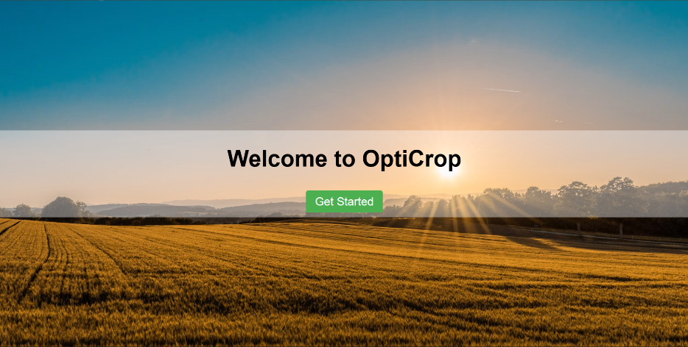

Screenshot 2 – Dashboard
Description
The Dashboard provides access to the crop recommendation module. It acts as the central interface after entering the application.
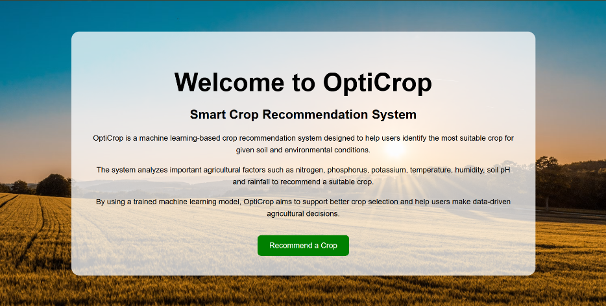

Screenshot 3 – Crop Recommendation Input Page
Description
Users enter agricultural parameters including:
- Nitrogen (N)
- Phosphorus (P)
- Potassium (K)
- Temperature
- Humidity
- Soil pH
- Rainfall
These values are submitted to the Machine Learning model for prediction.
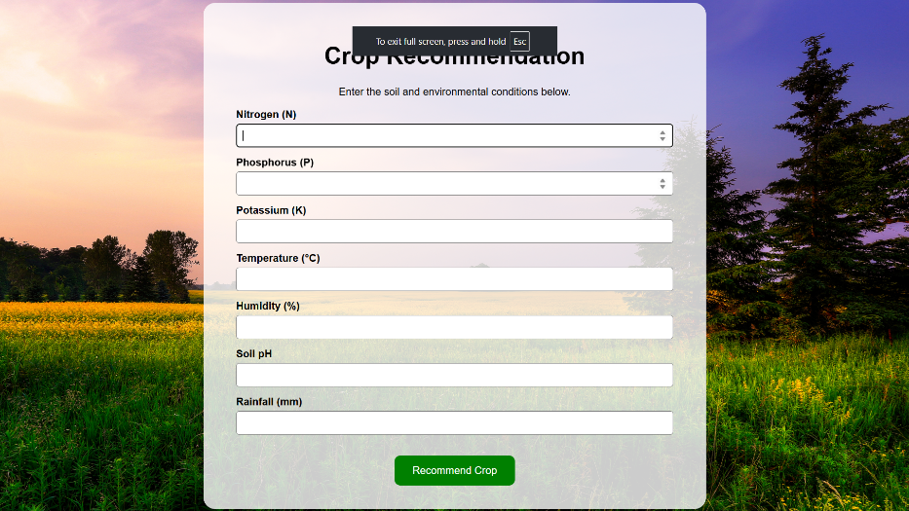

Screenshot 4 – Crop Recommendation Result
Description
After processing the user inputs, the Machine Learning model predicts the most suitable crop. The recommendation is displayed on the result page, enabling users to make informed agricultural decisions.
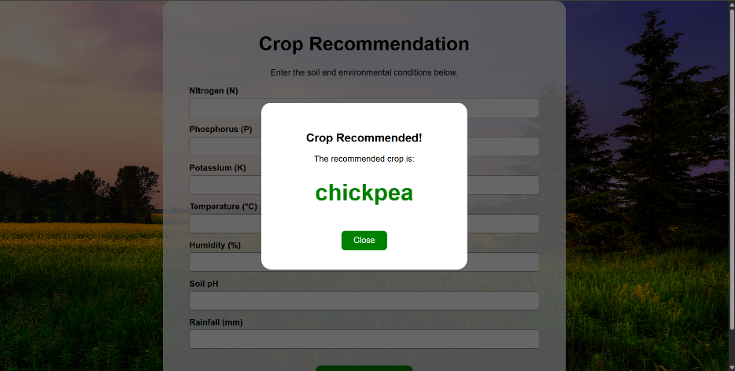

Overall Results
The developed application successfully integrates Machine Learning with a Flask web application to provide crop recommendations based on agricultural parameters. The prediction model produces accurate recommendations within a short response time, demonstrating the effectiveness of Artificial Intelligence in supporting agricultural decision-making.
The project achieved its primary objective of developing a smart crop recommendation system that assists farmers in selecting appropriate crops according to soil characteristics and climatic conditions. The application is simple, reliable, and can serve as a foundation for future enhancements such as fertilizer recommendation, disease prediction, weather integration, and irrigation management.

8. ADVANTAGES & DISADVANTAGES
The OptiCrop: Smart Agricultural Production Optimization Engine was developed to assist farmers in selecting suitable crops based on soil nutrients and environmental conditions. By integrating Machine Learning with a web-based application, the system provides data-driven recommendations that support informed agricultural decision-making. Like any software application, the system has both advantages and limitations.

8.1 Advantages
The major advantages of the proposed system are as follows:

1. Accurate Crop Recommendation
The system utilizes a trained Machine Learning model to recommend the most suitable crop based on soil nutrients and climatic conditions, improving the accuracy of crop selection.

2. Easy to Use
The application provides a simple and user-friendly interface, allowing users to enter agricultural parameters and receive recommendations without requiring technical knowledge.

3. Fast Prediction
The Flask-based application processes user inputs quickly and generates crop recommendations within a few seconds, enabling efficient decision-making.

4. Data-Driven Decision Making
Instead of relying solely on traditional farming practices, the system uses agricultural datasets and Machine Learning techniques to provide scientific recommendations.

5. Resource Optimization
By recommending appropriate crops according to soil conditions, the system helps farmers utilize land and natural resources more effectively.

6. Scalable Design
The modular architecture allows future enhancements such as fertilizer recommendation, disease prediction, weather forecasting, irrigation management, and market price analysis.

8.2 Disadvantages
Despite its benefits, the current implementation has certain limitations.

1. Limited Functionality
The current system focuses only on crop recommendation and does not include additional agricultural advisory features.

2. Dependency on Input Accuracy
The quality of the recommendation depends entirely on the correctness of the values entered by the user. Incorrect inputs may lead to inaccurate predictions.

3. Static Dataset
The Machine Learning model is trained on an existing dataset and does not automatically update itself with new agricultural data.

4. No Real-Time Data Integration
The application does not currently integrate real-time weather information, IoT sensors, or live agricultural databases.

5. Internet Requirement
As a web-based application, users require internet access to use the system when it is deployed online.

6. Limited Regional Adaptability
The recommendation model is based on the available training dataset and may require retraining with region-specific agricultural data for improved local accuracy.

Summary
The OptiCrop system successfully demonstrates how Machine Learning can support agricultural decision-making through intelligent crop recommendations. Although the current implementation is limited to crop recommendation, it provides a strong foundation for developing a comprehensive smart agriculture platform in the future. With additional modules and real-time data integration, the system can evolve into a more powerful decision-support solution for farmers.

9. CONCLUSION
The OptiCrop: Smart Agricultural Production Optimization Engine was successfully developed as a Machine Learning-based web application that assists farmers in selecting suitable crops based on soil nutrient values and environmental conditions. The project demonstrates the practical application of Artificial Intelligence and Machine Learning in agriculture by providing accurate, data-driven crop recommendations through a simple and interactive web interface.
The application accepts important agricultural parameters, including Nitrogen (N), Phosphorus (P), Potassium (K), temperature, humidity, soil pH, and rainfall. These inputs are processed using a trained Machine Learning model, which predicts the most suitable crop for cultivation. The integration of the Machine Learning model with the Flask web framework enables users to obtain recommendations quickly and efficiently.
Throughout the project, all phases of the Software Development Life Cycle (SDLC) were completed systematically, including problem identification, requirement analysis, project design, implementation, testing, and documentation. Functional testing and performance testing confirmed that the application operates correctly and generates crop recommendations with satisfactory accuracy and response time.
The developed system provides a user-friendly platform that simplifies crop selection and supports informed agricultural decision-making. By leveraging historical agricultural data and predictive analytics, the application helps farmers choose crops that are better suited to their soil and climatic conditions, thereby contributing to improved productivity and efficient resource utilization.
In conclusion, the OptiCrop project successfully achieved its primary objective of developing an intelligent crop recommendation system. The project serves as a practical example of how Machine Learning can be applied to modern agriculture and provides a strong foundation for future enhancements that can further support precision farming and sustainable agricultural development.

10. FUTURE SCOPE
The current implementation of the OptiCrop: Smart Agricultural Production Optimization Engine focuses on providing intelligent crop recommendations using Machine Learning. Although the system successfully achieves its primary objective, there are several opportunities for future enhancements that can improve its functionality, accuracy, and overall usefulness for farmers.
Future versions of the application can incorporate additional Artificial Intelligence and smart farming technologies to provide a more comprehensive agricultural decision-support system.

Future Enhancements

1. Fertilizer Recommendation
A fertilizer recommendation module can be integrated to suggest the most suitable fertilizers based on soil nutrient levels and the recommended crop. This will help farmers improve soil fertility and optimize fertilizer usage.

2. Crop Disease Detection
The system can be enhanced with a crop disease prediction module using image processing and deep learning techniques. Farmers will be able to upload images of crop leaves to identify diseases at an early stage.

3. Weather Forecast Integration
Integration with real-time weather APIs can provide accurate weather forecasts, enabling farmers to plan irrigation, sowing, and harvesting activities more effectively.

4. Irrigation Recommendation
A smart irrigation module can be developed to recommend the optimal amount of water required based on soil moisture, weather conditions, and crop type, helping conserve water resources.

5. Mobile Application
Developing an Android and iOS mobile application would make the system more accessible, allowing farmers to use the platform directly from their smartphones.

6. Regional Language Support
Adding support for multiple regional languages will improve accessibility and make the application easier to use for farmers from different regions.

7. Cloud Deployment
Deploying the application on a cloud platform would improve scalability, availability, and accessibility, allowing users to access the system from anywhere with an internet connection.

8. Continuous Model Improvement
The Machine Learning model can be periodically retrained using updated agricultural datasets to improve prediction accuracy and adapt to changing environmental conditions.

Summary
The current project provides a strong foundation for intelligent crop recommendation using Machine Learning. By incorporating advanced technologies such as real-time weather services, IoT devices, deep learning, cloud computing, and mobile applications, the system can evolve into a comprehensive smart agriculture platform that supports precision farming, sustainable resource management, and improved agricultural productivity.

11. APPENDIX
The appendix contains additional information and resources related to the implementation of the OptiCrop: Smart Agricultural Production Optimization Engine. These resources provide supporting material for the project, including source code, datasets, and repository details.

11.1 Source Code
The complete source code for the project includes the following components:
- Flask Web Application
- Machine Learning Model
- HTML Templates
- CSS and JavaScript Files
- Static Resources
- Crop Recommendation Logic
- Trained Machine Learning Model (.pkl)
- Dataset Files
The source code is organized into separate folders for easy maintenance and future enhancements.

11.2 Dataset
The Machine Learning model was trained using a publicly available Crop Recommendation Dataset containing agricultural parameters such as:
- Nitrogen (N)
- Phosphorus (P)
- Potassium (K)
- Temperature
- Humidity
- Soil pH
- Rainfall
- Crop Label
The dataset was preprocessed before training to improve prediction accuracy and ensure reliable recommendations.
Dataset Link:
Click_Here

11.3 GitHub Repository
The complete project source code is maintained in a GitHub repository to support version control and collaboration.
GitHub Repository Link:
Click_Here

11.4 Project Demonstration
A demonstration of the application can be provided through a video or a hosted deployment, allowing users to understand the workflow and functionality of the system.
Project Demo Link:
(Insert Demo Video or Deployment Link Here)

11.5 Software Requirements
The following software was used to develop and test the project:
Software | Version
Python | 3.x
Flask | Latest Stable Version
Visual Studio Code | Latest Version
Scikit-learn | Latest Stable Version
Pandas | Latest Stable Version
NumPy | Latest Stable Version
Git | Latest Version
GitHub | Cloud Repository

11.6 Hardware Requirements
Component | Specification
Processor | Intel Core i3 or above
RAM | Minimum 4 GB (8 GB Recommended)
Storage | 2 GB Free Space
Operating System | Windows 10/11 or Linux
Internet | Required for downloading dependencies and repository access

11.7 Abbreviations
Abbreviation | Meaning
AI | Artificial Intelligence
ML | Machine Learning
SDLC | Software Development Life Cycle
UI | User Interface
N | Nitrogen
P | Phosphorus
K | Potassium
HTML | HyperText Markup Language
CSS | Cascading Style Sheets
API | Application Programming Interface

References
- Han, J., Kamber, M., & Pei, J. Data Mining: Concepts and Techniques. Morgan Kaufmann.
- Géron, A. Hands-On Machine Learning with Scikit-Learn, Keras & TensorFlow. O'Reilly Media.
- Scikit-learn Documentation – https://scikit-learn.org
- Flask Documentation – https://flask.palletsprojects.com
- Pandas Documentation – https://pandas.pydata.org
- NumPy Documentation – https://numpy.org
- Kaggle Crop Recommendation Dataset – https://www.kaggle.com/datasets/chitrakumari25/smart-agricultural-production-optimizing-engine

